|  |  |
| --- | --- |
| Project Title | **Customer Satisfaction Prediction** |
| language | Machine learning, python, SQL, Excel |
| Tools | VS code, Jupyter notebook |
| Domain | Data Science |
| Project Difficulties level | Advance |

Dataset : Dataset is available in the given link. You can download it at your convenience.

[Click](https://drive.google.com/file/d/1DRdLKOinSNuoMwVyFGH86f3xEhkZMrz6/view?usp=sharing) [here](https://drive.google.com/file/d/1DRdLKOinSNuoMwVyFGH86f3xEhkZMrz6/view?usp=sharing) [to](https://drive.google.com/file/d/1DRdLKOinSNuoMwVyFGH86f3xEhkZMrz6/view?usp=sharing) [download](https://drive.google.com/file/d/1DRdLKOinSNuoMwVyFGH86f3xEhkZMrz6/view?usp=sharing) [data](https://drive.google.com/file/d/1DRdLKOinSNuoMwVyFGH86f3xEhkZMrz6/view?usp=sharing) [set](https://drive.google.com/file/d/1DRdLKOinSNuoMwVyFGH86f3xEhkZMrz6/view?usp=sharing)

**About Dataset**

The Customer Support Ticket Dataset is a dataset that includes customer support tickets for various tech products. It consists of customer inquiries related to hardware issues, software bugs, network problems, account access, data loss, and other support topics. The dataset provides information about the customer, the product purchased, the ticket type, the ticket channel, the ticket status, and other relevant details.

The dataset can be used for various analysis and modelling tasks in the customer service domain.

**Features Description:**

* Ticket ID: A unique identifier for each ticket.
* Customer Name: The name of the customer who raised the ticket.
* Customer Email: The email address of the customer (Domain name [@example.com](https://www.kaggle.com/example.com) is intentional for user data privacy concern).
* Customer Age: The age of the customer.
* Customer Gender: The gender of the customer.
* Product Purchased: The tech product purchased by the customer.
* Date of Purchase: The date when the product was purchased.
* Ticket Type: The type of ticket (e.g., technical issue, billing inquiry, product inquiry).
* Ticket Subject: The subject/topic of the ticket.
* Ticket Description: The description of the customer's issue or inquiry.
* Ticket Status: The status of the ticket (e.g., open, closed, pending customer response).
* Resolution: The resolution or solution provided for closed tickets.
* Ticket Priority: The priority level assigned to the ticket (e.g., low, medium, high, critical).
* Ticket Channel: The channel through which the ticket was raised (e.g., email, phone, chat, social media).
* First Response Time: The time taken to provide the first response to the customer.
* Time to Resolution: The time taken to resolve the ticket.
* Customer Satisfaction Rating: The customer's satisfaction rating for closed tickets (on a scale of 1 to 5).

**Use Cases of such dataset:**

* Customer Support Analysis: The dataset can be used to analyze customer support ticket trends, identify common issues, and improve support processes.
* Natural Language Processing (NLP): The ticket descriptions can be used for training NLP models to automate ticket categorization or sentiment analysis.
* Customer Satisfaction Prediction: The dataset can be used to train models to predict customer satisfaction based on ticket information.
* Ticket Resolution Time Prediction: The dataset can be used to build models for predicting the time it takes to resolve a ticket based on various factors.
* Customer Segmentation: The dataset can be used to segment customers based on their ticket types, issues, or satisfaction levels.
* Recommender Systems: The dataset can be used to build recommendation systems for suggesting relevant solutions or products based on customer inquiries.

**Example: You can get the basic idea how you can create a project from here**

**Customer Satisfaction Prediction Machine Learning Project**

**Project Overview**

The goal of this project is to predict customer satisfaction using historical data. This involves using machine learning algorithms to analyze factors that influence customer satisfaction and build a predictive model.

**Dataset**

A commonly used dataset for this type of project is the "Customer Satisfaction Survey" dataset, which includes features such as:

* **CustomerID**
* **Age**
* **Gender**
* **Income**
* **Education Level**
* **Product Purchased**
* **Purchase Frequency**
* **Customer Service Interactions**
* **Feedback Scores**
* **Overall Satisfaction**

This dataset can be found on platforms like Kaggle or UCI Machine Learning Repository.

**Steps and Implementation**

1. **Data Preprocessing**
2. **Exploratory Data Analysis (EDA)**
3. **Feature Engineering**
4. **Model Building**
5. **Model Evaluation**
6. **Visualization**

**Implementation Code**

Here is a sample implementation in Python:

|  |
| --- |
| # Importing necessary libraries import pandas as pd import numpy as np  import matplotlib.pyplot as plt import seaborn as sns  from sklearn.model_selection import train_test_split  from sklearn.preprocessing import StandardScaler, LabelEncoder from sklearn.ensemble import RandomForestClassifier  from sklearn.metrics import accuracy_score, classification_report, confusion_matrix  # Load the dataset  data = pd.read_csv('customer_satisfaction.csv')  # Display basic info about the dataset  print(data.info())  # Data Preprocessing # Handling missing values data = data.dropna()  # Encoding categorical variables |

|  |
| --- |
| label_encoders = {} for column in data.select_dtypes(include=['object']).columns:  label_encoders[column] = LabelEncoder()  data[column] = label_encoders[column].fit_transform(data[column])  # Define features and target variable  X = data.drop(['CustomerID', 'Overall Satisfaction'], axis=1) y = data['Overall Satisfaction']  # Splitting the dataset  X_train, X_test, y_train, y_test = train_test_split(X, y, test_size=0.3, random_state=42)  # Feature Scaling scaler = StandardScaler()  X_train = scaler.fit_transform(X_train)  X_test = scaler.transform(X_test)  # Model Building  # Train a Random Forest Classifier  rfc = RandomForestClassifier(random_state=42) rfc.fit(X_train, y_train)  # Predict on the test set y_pred = rfc.predict(X_test)  # Model Evaluation  print("Accuracy:", accuracy_score(y_test, y_pred))  print("Classification Report:\n", classification_report(y_test, y_pred)) |
| print("Confusion Matrix:\n", confusion_matrix(y_test, y_pred))  # Visualization of Results # Feature Importance  feature_importances = pd.Series(rfc.feature_importances_, index=X.columns) feature_importances.nlargest(10).plot(kind='barh') plt.title('Top 10 Feature Importances') plt.show() |

**Example: You can get the basic idea how you can create a project from here**

**Explanation of Code**

1. **Data Preprocessing:**
   1. Load the dataset and display basic information.

○ Handle missing values by dropping rows with NA values.

○ Encode categorical variables using LabelEncoder.

1. **Exploratory Data Analysis (EDA):**
   1. Although not shown in the code snippet, EDA typically involves visualizing data distributions, correlations, and patterns using libraries like matplotlib and seaborn.
2. **Feature Engineering:**
   1. Define the feature set X and the target variable y.

○ Split the data into training and testing sets using train_test_split.

1. **Feature Scaling:**
   1. Standardize the features using StandardScaler to ensure all features contribute equally to the model.
2. **Model Building:**
   1. Train a RandomForestClassifier on the training data.

○ Predict customer satisfaction on the test data.

1. **Model Evaluation:**
   1. Evaluate the model using metrics like accuracy, classification report, and confusion matrix.

○ Visualize the top 10 feature importances to understand which factors contribute most to customer satisfaction.

**Additional Resources**

* [Customer](https://www.kaggle.com/) [Satisfaction](https://www.kaggle.com/) [Survey](https://www.kaggle.com/) [Data](https://www.kaggle.com/) [on](https://www.kaggle.com/) [Kaggle](https://www.kaggle.com/)
* Random Forest Classifier Documentation
* Handling Missing Data in Pandas
* Feature Scaling with StandardScaler

This implementation provides a framework for predicting customer satisfaction using machine learning. You can extend it by experimenting with different algorithms, fine-tuning hyperparameters, and incorporating additional features to improve the model's performance.

**Sample code with output**

import pandas as pd import matplotlib.pyplot as plt import seaborn as sns import numpy as np from sklearn.feature_extraction.text import CountVectorizer from sklearn.model_selection import train_test_split

|  |
| --- |
| from sklearn.linear_model import LinearRegression from sklearn.metrics import mean_squared_error from sklearn.cluster import KMeans  *# Load the dataset* data = pd.read_csv("/kaggle/input/customer-support-ticket-dataset/cust omer_support_tickets.csv")  *# Display the first few rows of the dataset* print(data.head())  *# Perform initial exploratory data analysis (EDA)* print(data.info()) print(data.describe())  Ticket ID Customer Name Customer Email  Customer Age \   1. 1 Marisa Obrien carrollallison@example.com   32   1. 2 Jessica Rios clarkeashley@example.com   42   1. 3 Christopher Robbins gonzalestracy@example.com   48 |

1. 4 Christina Dillon bradleyolson@example.org

27

1. 5 Alexander Carroll bradleymark@example.com

67

Customer Gender Product Purchased Date of Purchase

Ticket Type \

1. Other GoPro Hero 2021-03-22 Technical issue
2. Female LG Smart TV 2021-05-22 Technical issue
3. Other Dell XPS 2020-07-14 Technical issue
4. Female Microsoft Office 2020-11-13 Billing inquiry
5. Female Autodesk AutoCAD 2020-02-04 Billing

inquiry

Ticket Subject \

1. Product setup
2. Peripheral compatibility
3. Network problem
4. Account access
5. Data loss

Ticket Description \ 0 I'm having an issue with the {product_purchase...

1. I'm having an issue with the {product_purchase...
2. I'm facing a problem with my {product_purchase...
3. I'm having an issue with the {product_purchase...
4. I'm having an issue with the {product_purchase...

Ticket Status

Resolution \

1. Pending Customer Response

NaN

1. Pending Customer Response

NaN

1. Closed Case maybe show recently my computer follow.
2. Closed Try capital clearly never color toward story.
3. Closed West decision evidence bit.

Ticket Priority Ticket Channel First Response Time Time to

Resolution \

1. Critical Social media 2023-06-01 12:15:36

NaN

1. Critical Chat 2023-06-01 16:45:38

NaN

|  |  |
| --- | --- |
| 1. Low Social media 2023-06-01 11:14:38   2023-06-01 18:05:38   1. Low Social media 2023-06-01 07:29:40   2023-06-01 01:57:40   1. Low Email 2023-06-01 00:12:42 | |
| 2023-06-01 19:53:42  Customer Satisfaction Rating   1. NaN 2. NaN 3. 3.0 4. 3.0 5. 1.0   <class 'pandas.core.frame.DataFrame'>  RangeIndex: 8469 entries, 0 to 8468 Data columns (total 17 columns): |  |
| # Column Non-Null Count | Dtype |
| --- ------ -------------- | ----- |
| 0 Ticket ID 8469 non-null | int64 |
| 1 Customer Name 8469 non-null | object |
| 2 Customer Email 8469 non-null | object |
| 3 Customer Age 8469 non-null | int64 |
| 4 Customer Gender 8469 non-null | object |
| 5 Product Purchased 8469 non-null | object |

|  |
| --- |
| 1. Date of Purchase 8469 non-null object 2. Ticket Type 8469 non-null object 3. Ticket Subject 8469 non-null object 4. Ticket Description 8469 non-null object 5. Ticket Status 8469 non-null object 6. Resolution 2769 non-null object 7. Ticket Priority 8469 non-null object 8. Ticket Channel 8469 non-null object 9. First Response Time 5650 non-null object 10. Time to Resolution 2769 non-null object 11. Customer Satisfaction Rating 2769 non-null float64 dtypes: float64(1), int64(2), object(14) memory usage: 1.1+ MB   None  Ticket ID Customer Age Customer Satisfaction Rating count 8469.000000 8469.000000 2769.000000 mean 4235.000000 44.026804 2.991333 std 2444.934048 15.296112 1.407016 min 1.000000 18.000000 1.000000 25% 2118.000000 31.000000 2.000000  50% 4235.000000 44.000000 3.000000 75% 6352.000000 57.000000 4.000000 max 8469.000000 70.000000 5.000000 |

|  |
| --- |
| In [2]:  *# Print column names* print(data.columns)  Index(['Ticket ID', 'Customer Name', 'Customer Email',  'Customer Age',  'Customer Gender', 'Product Purchased', 'Date of Purchase',  'Ticket Type', 'Ticket Subject', 'Ticket Description', 'Ticket Status',  'Resolution', 'Ticket Priority', 'Ticket Channel',  'First Response Time', 'Time to Resolution',  'Customer Satisfaction Rating'], dtype='object')  In [3]:  *#Analyze customer support ticket trends*  *# Identify common issues* common_issues = data['Ticket Subject'].value_counts().head(10) print("Top 10 Common Issues:") print(common_issues)  *# Plotting ticket trends over time* |

|  |
| --- |
| data['Date of Purchase'] = pd.to_datetime(data['Date of Purchase']) data['YearMonth'] = data['Date of Purchase'].dt.to_period('M') ticket_trends = data.groupby('YearMonth').size()  plt.figure(figsize=(10, 6)) ticket_trends.plot(kind='line', marker='o') plt.title('Customer Support Ticket Trends Over Time') plt.xlabel('Year-Month') plt.ylabel('Number of Tickets') plt.grid(True) plt.xticks(rotation=45) plt.tight_layout() plt.show()  Top 10 Common Issues:  Ticket Subject  Refund request 576  Software bug 574  Product compatibility 567  Delivery problem 561  Hardware issue 547  Battery life 542  Network problem 539 |

Installation

support

530

Product

setup

529

Payment

issue

526

Name:

count,

dtype:

int64

In

[4]:

*#*

*Segment*

*customers*

*#*

*Segment*

*based*

*on*

*ticket*

*types*

ticket_type_segmentation

=

data

.

groupby(

'Ticket

Type'

)

.

size()

print

(

"

**\n**

Segmentation

based

on

Ticket

Types:"

)

print

(

ticket_type_segmentation

)

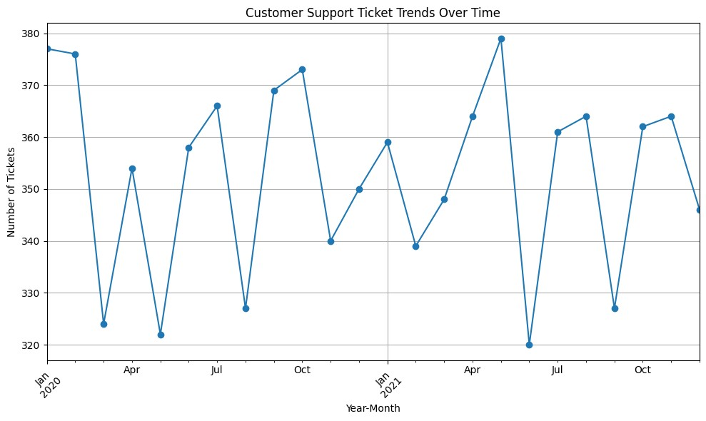

|  |
| --- |
| *# Segment based on satisfaction levels*  satisfaction_segmentation = data.groupby('Customer Satisfaction Rating').size() print("**\n**Segmentation based on Customer Satisfaction Levels:") print(satisfaction_segmentation)  Segmentation based on Ticket Types:  Ticket Type  Billing inquiry 1634  Cancellation request 1695  Product inquiry 1641  Refund request 1752 Technical issue 1747  dtype: int64  Segmentation based on Customer Satisfaction Levels:  Customer Satisfaction Rating  1.0 553  2.0 549  3.0 580  4.0 543  5.0 544  dtype: int64 |

|  |
| --- |
| In [5]:  *# Set up the plotting aesthetics* sns.set(style="whitegrid")  *#Customer Satisfaction Distribution* plt.figure(figsize=(10, 6)) sns.histplot(data['Customer Satisfaction Rating'], bins=5, kde=True, color='skyblue') plt.title('Customer Satisfaction Distribution') plt.xlabel('Satisfaction Rating') plt.ylabel('Frequency') plt.show()  /opt/conda/lib/python3.10/site-packages/seaborn/_oldcore.py:111 9: FutureWarning: use_inf_as_na option is deprecated and will be removed in a future version. Convert inf values to NaN before operating instead.  with pd.option_context('mode.use_inf_as_na', True): |

In

[6]:

*#Ticket*

*Status*

*Distribution*

ticket_status_distribution

=

data[

'Ticket

Status'

]

.

value_counts()

plt

.

figure(figsize

=

(

8

,

8

))

plt

.

pie(ticket_status_distribution,

labels

=

ticket_status_distribution

.

index,

autopct

=

'

**%1.1f%%**

'

,

colors

=

sns

.

color_palette(

'pastel'

)

,

startangle

=

140

)

plt

.

title(

'Ticket

Status

Distribution'

)

plt

.

axis(

'equal'

)

plt

.

show()

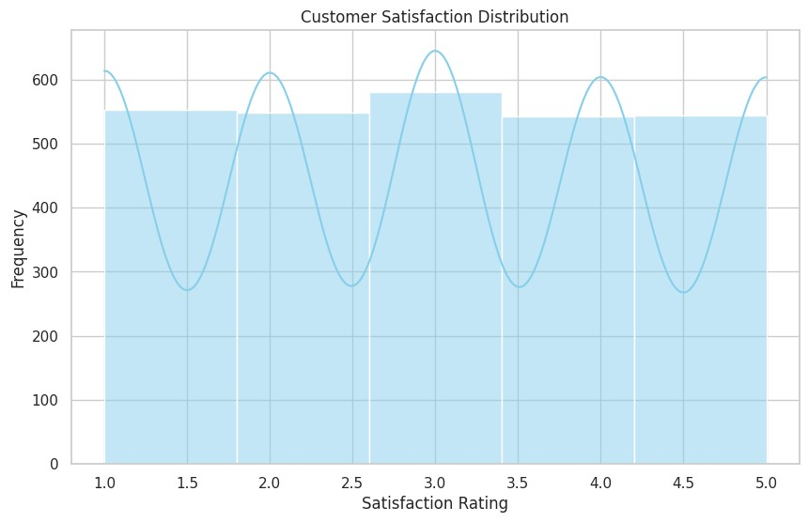

In

[7]:

*#Customer*

*Age*

*Distribution*

plt

.

figure(figsize

=

(

10

,

6

))

sns

.

histplot(data[

'Customer

Age'

]

,

bins

=

20

,

kde

=

True

,

color

=

'salmon'

)

plt

.

title(

'Customer

Age

Distribution'

)

plt

.

xlabel(

'Age'

)

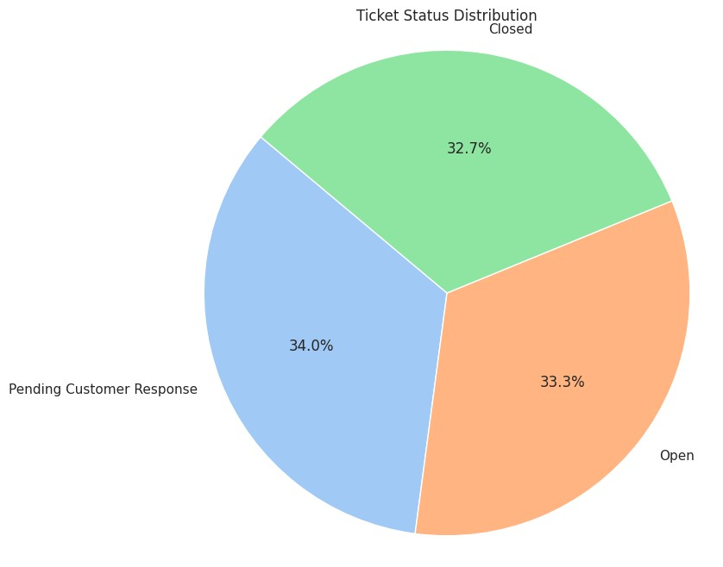

plt

.

ylabel(

'Frequency'

)

plt

.

show()

/opt/conda/lib/python3.10/site-packages/seaborn/_oldcore.py:111

9:

FutureWarning:

use_inf_as_na

option

is

deprecated

and

will

be

removed

in

a

future

version.

Convert

inf

values

to

NaN

before

operating

instead.

with

pd.option_context('mode.use_inf_as_na',

True):

In

[8]:

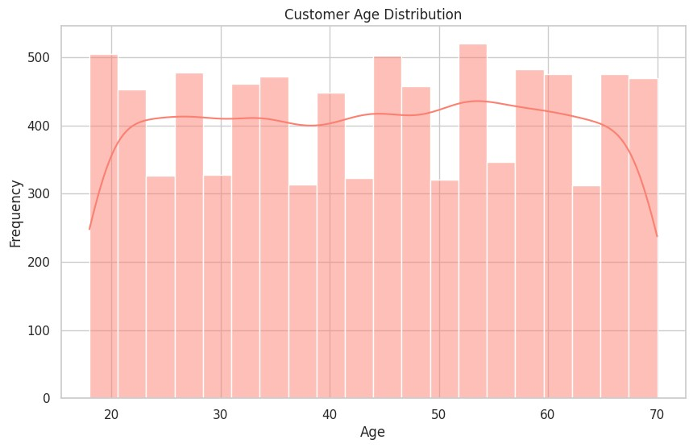

|  |
| --- |
| *#Customer Gender Distribution*  customer_gender_distribution = data['Customer Gender'].value_counts() plt.figure(figsize=(8, 8)) plt.pie(customer_gender_distribution, labels=customer_gender_distribution.index, autopct='**%1.1f%%**', colors=sns.color_palette('Set2'), startangle=90) plt.title('Customer Gender Distribution') plt.axis('equal') plt.show() |

In

[9]:

*#Ticket*

*Channel*

*Distribution*

plt

.

figure(figsize

=

(

10

,

6

))

ticket_channel_distribution

=

data[

'Ticket

Channel'

]

.

value_counts()

sns

.

barplot(x

=

ticket_channel_distribution

.

index,

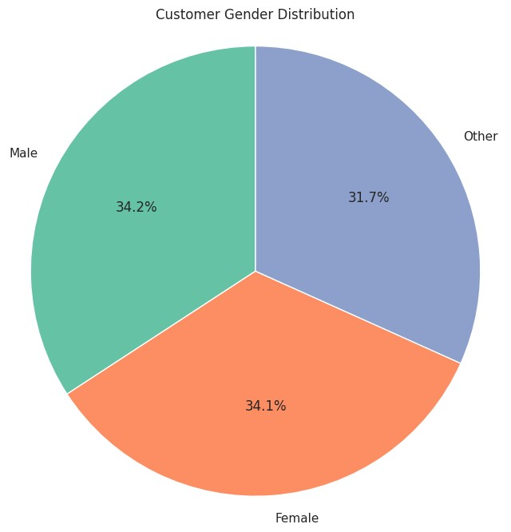

y

=

ticket_channel_distribution,

palette

=

'rocket'

)

plt

.

title(

'Ticket

Channel

Distribution'

)

plt

.

xlabel(

'Ticket

Channel'

)

plt

.

ylabel(

'Count'

)

plt

.

xticks(rotation

=

45

)

plt

.

show()

In

[10]:

*#*

*Chart*

*1:*

*Average*

*Customer*

*Satisfaction*

*by*

*Gender*

*(*

*Bar*

*Plot)*

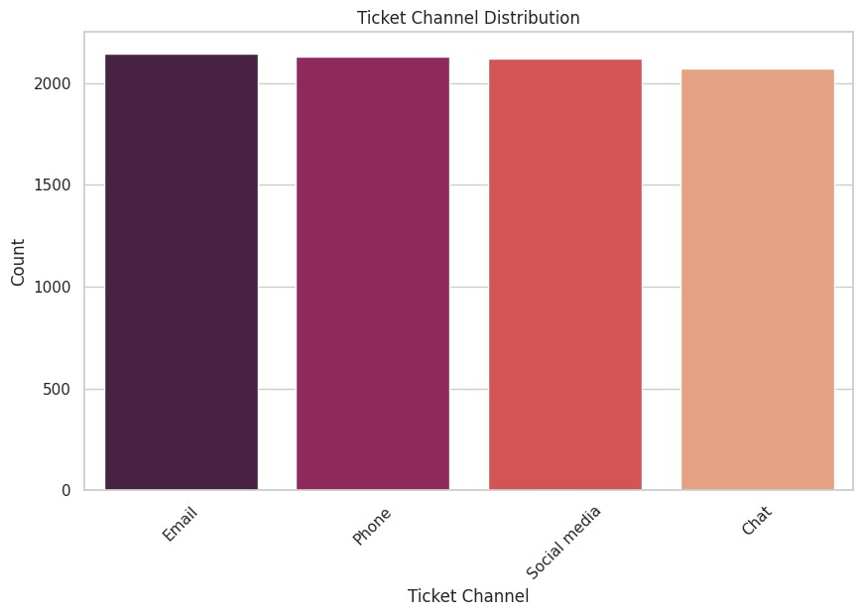

|  |
| --- |
| average_satisfaction = data.groupby('Customer  Gender')['Customer Satisfaction Rating'].mean().reset_index()  plt.figure(figsize=(8, 6))  sns.barplot(x='Customer Gender', y='Customer Satisfaction Rating', data=average_satisfaction, palette='muted', order=['Male', 'Female', 'Other']) plt.title('Average Customer Satisfaction by Gender') plt.xlabel('Gender') plt.ylabel('Average Satisfaction Rating') plt.ylim(1, 5) *# Adjust y-axis limit if needed* plt.show() |

In

[11]:

*#Product*

*Purchased*

*Distribution*

plt

.

figure(figsize

=

(

10

,

6

))

product_purchased_distribution

=

data[

'Product

Purchased'

]

.

value_counts()

.

head(

10

)

sns

.

barplot(y

=

product_purchased_distribution

.

index,

x

=

product_purchased_distribution,

palette

=

'magma'

)

plt

.

title(

'Top

10

Products

Purchased'

)

plt

.

xlabel(

'Count'

)

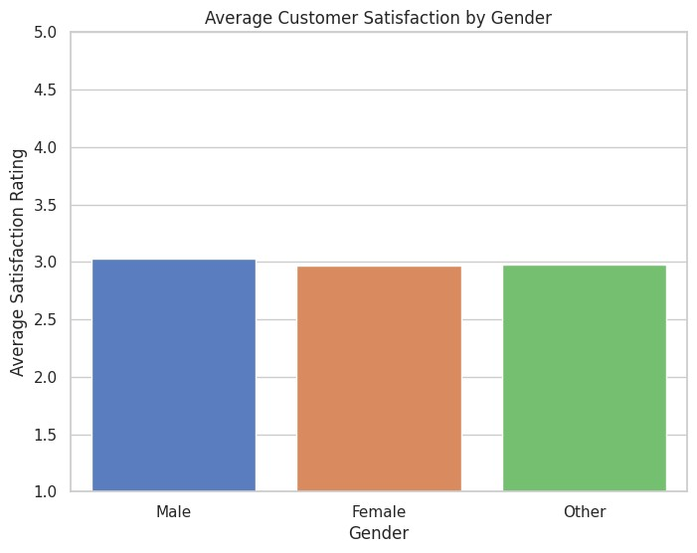

plt

.

ylabel(

'Product'

)

plt

.

show()

In

[12]:

*#*

*Chart*

*2:*

*Top*

*Items*

*Purchased*

*by*

*Gender*

*(*

*Horizontal*

*Bar*

*Chart)*

plt

.

figure(figsize

=

(

15

,

6

))

*#*

*Top*

*Items*

*Purchased*

*by*

*Males*

plt

.

subplot(

1

,

3

,

1

)

top_items_male

=

data[data[

'Customer

Gender'

]

==

'Male'

][

'Product

Purchased'

]

.

value_counts()

.

head(

5

)

top_items_male

.

plot(kind

=

'barh'

,

color

=

'skyblue'

)

plt

.

title(

'Top

Items

Purchased

by

Males'

)

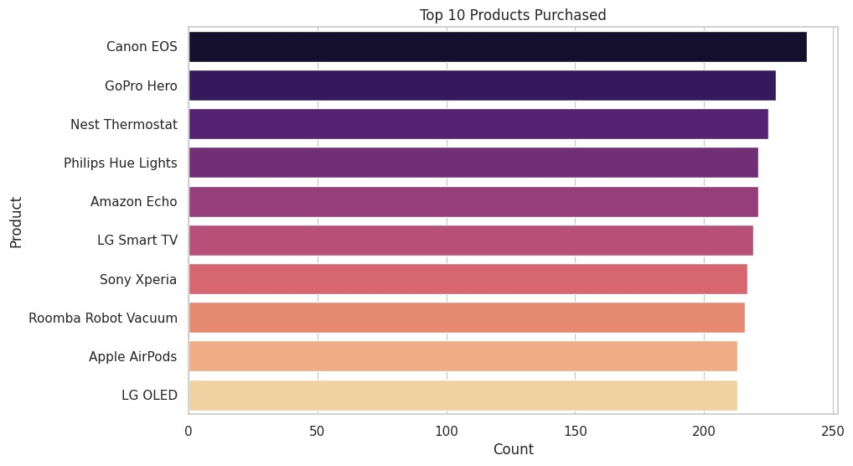

|  |
| --- |
| plt.xlabel('Count') plt.ylabel('Product')  *# Top Items Purchased by Females* plt.subplot(1, 3, 2) top_items_female = data[data['Customer Gender'] == 'Female']['Product Purchased'].value_counts().head(5) top_items_female.plot(kind='barh', color='salmon') plt.title('Top Items Purchased by Females') plt.xlabel('Count') plt.ylabel('Product')  *# Top Items Purchased by Other Gender* plt.subplot(1, 3, 3) top_items_other = data[data['Customer Gender'] == 'Other']['Product Purchased'].value_counts().head(5) top_items_other.plot(kind='barh', color='lightgreen') plt.title('Top Items Purchased by Other Genders') plt.xlabel('Count') plt.ylabel('Product')  plt.tight_layout() plt.show() |

In

[13]:

*#*

*Count*

*ticket*

*types*

ticket_type_distribution

=

data[

'Ticket

Type'

]

.

value_counts()

*#*

*Plot*

plt

.

figure(figsize

=

(

8

,

6

))

ticket_type_distribution

.

plot(kind

=

'pie'

,

autopct

=

'

**%1.1f%%**

'

,

colors

=

[

'skyblue'

,

'salmon'

,

'lightgreen'

])

plt

.

title(

'Ticket

Type

Distribution'

)

plt

.

ylabel(

''

)

plt

.

show()

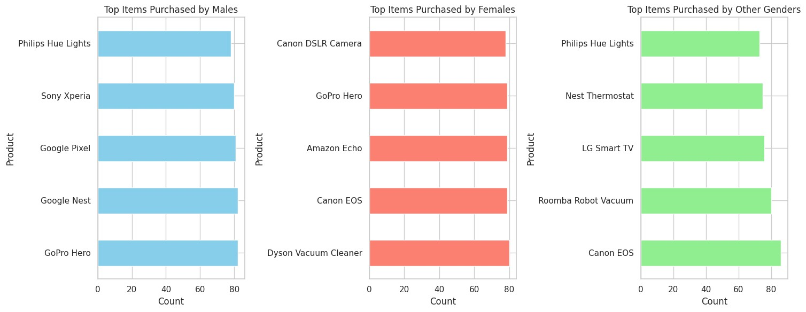

In

[14]:

*#*

*Count*

*ticket*

*priorities*

priority_distribution

=

data[

'Ticket

Priority'

]

.

value_counts()

*#*

*Plot*

plt

.

figure(figsize

=

(

8

,

6

))

priority_distribution

.

plot(kind

=

'pie'

,

autopct

=

'

**%1.1f%%**

'

,

colors

=

[

'lightblue'

,

'lightgreen'

,

'lightsalmon'

,

'skyblue'

])

plt

.

title(

'Priority

Level

Distribution'

)

plt

.

ylabel(

''

)

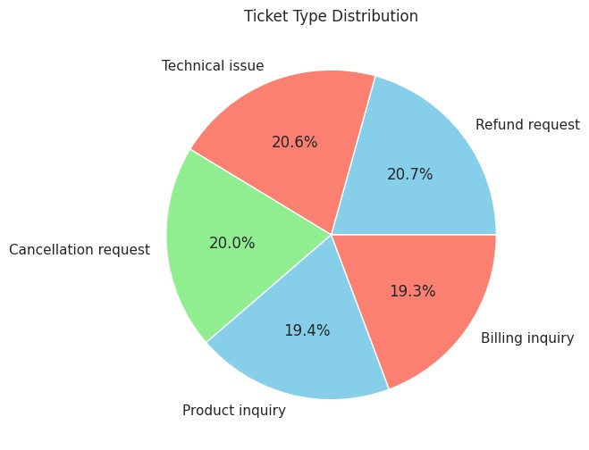

plt

.

show()

In

[15]:

*#*

*Define*

*age*

*groups*

bins

=

[

0

,

20

,

30

,

40

,

50

,

60

,

70

,

80

,

90

,

100

]

labels

=

[

'0-20'

,

'21-30'

,

'31-40'

,

'41-50'

,

'51-60'

,

'61-70'

,

'71-80'

,

'81-90'

,

'91-100'

]

*#*

*Categorize*

*customers*

*into*

*age*

*groups*

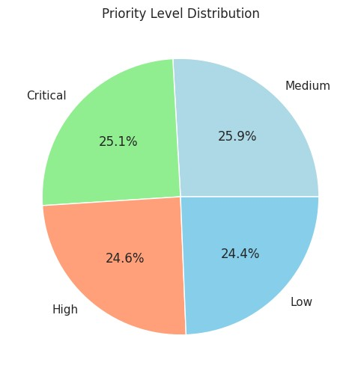

|  |
| --- |
| data['Age Group'] = pd.cut(data['Customer Age'], bins=bins, labels=labels, right=False)  *# Calculate number of tickets raised by each age group* tickets_by_age_group = data.groupby('Age Group').size()  *# Plot* plt.figure(figsize=(10, 6)) tickets_by_age_group.plot(kind='bar', color='skyblue') plt.title('Tickets Raised by Age Group') plt.xlabel('Age Group') plt.ylabel('Number of Tickets Raised') plt.xticks(rotation=45) plt.grid(axis='y') plt.show()  /tmp/ipykernel_18/91670186.py:9: FutureWarning: The default of observed=False is deprecated and will be changed to True in a future version of pandas. Pass observed=False to retain current behavior or observed=True to adopt the future default and silence this warning.  tickets_by_age_group = data.groupby('Age Group').size() |

In

[16]:

linkcode

*#*

*Replace*

*inf*

*values*

*with*

*NaN*

data

.

replace([np

.

inf,

-

np

.

inf],

np

.

nan,

inplace

=

True

)

*#*

*Create*

*a*

*facet*

*grid*

*for*

*each*

*ticket*

*type*

g

=

sns

.

FacetGrid(data,

col

=

'Ticket

Type'

,

col_wrap

=

3

,

height

=

5

,

aspect

=

1.5

)

g

.

map(sns

.

histplot,

'Customer

Age'

,

bins

=

20

,

kde

=

True

)

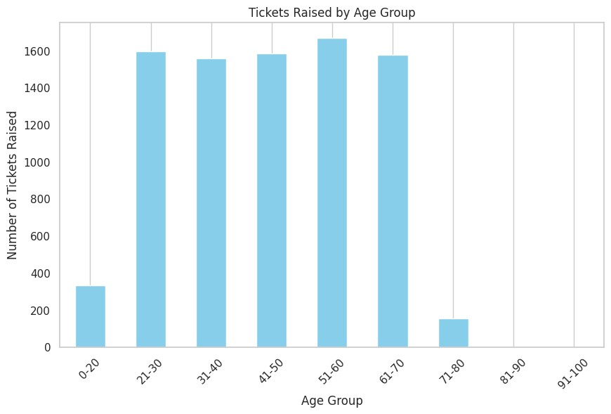

|  |
| --- |
| *# Set titles and labels*  g.set_titles('**{col_name}**')  g.set_axis_labels('Age', 'Number of Tickets')  *# Adjust layout* plt.subplots_adjust(top=0.9)  g.fig.suptitle('Distribution of Ticket Types by Age')  *# Show plot* plt.show()  /opt/conda/lib/python3.10/site-packages/seaborn/_oldcore.py:111 9: FutureWarning: use_inf_as_na option is deprecated and will be removed in a future version. Convert inf values to NaN before operating instead.  with pd.option_context('mode.use_inf_as_na', True):  /opt/conda/lib/python3.10/site-packages/seaborn/_oldcore.py:111 9: FutureWarning: use_inf_as_na option is deprecated and will be removed in a future version. Convert inf values to NaN before operating instead. with pd.option_context('mode.use_inf_as_na', True):  /opt/conda/lib/python3.10/site-packages/seaborn/_oldcore.py:111 9: FutureWarning: use_inf_as_na option is deprecated and will be removed in a future version. Convert inf values to NaN |

before

operating

instead.

with

pd.option_context('mode.use_inf_as_na',

True):

/opt/conda/lib/python3.10/site-packages/seaborn/_oldcore.py:111

9:

FutureWarning:

use_inf_as_na

option

is

deprecated

and

will

be

removed

in

a

future

version.

Convert

inf

values

to

NaN

before

operating

instead.

with

pd.option_context('mode.use_inf_as_na',

True):

/opt/conda/lib/python3.10/site-packages/seaborn/_oldcore.py:111

9:

FutureWarning:

use_inf_as_na

option

is

deprecated

and

will

be

removed

in

a

future

version.

Convert

inf

values

to

NaN

before

operating

instead.

with

pd.option_context('mode.use_inf_as_na',

True):

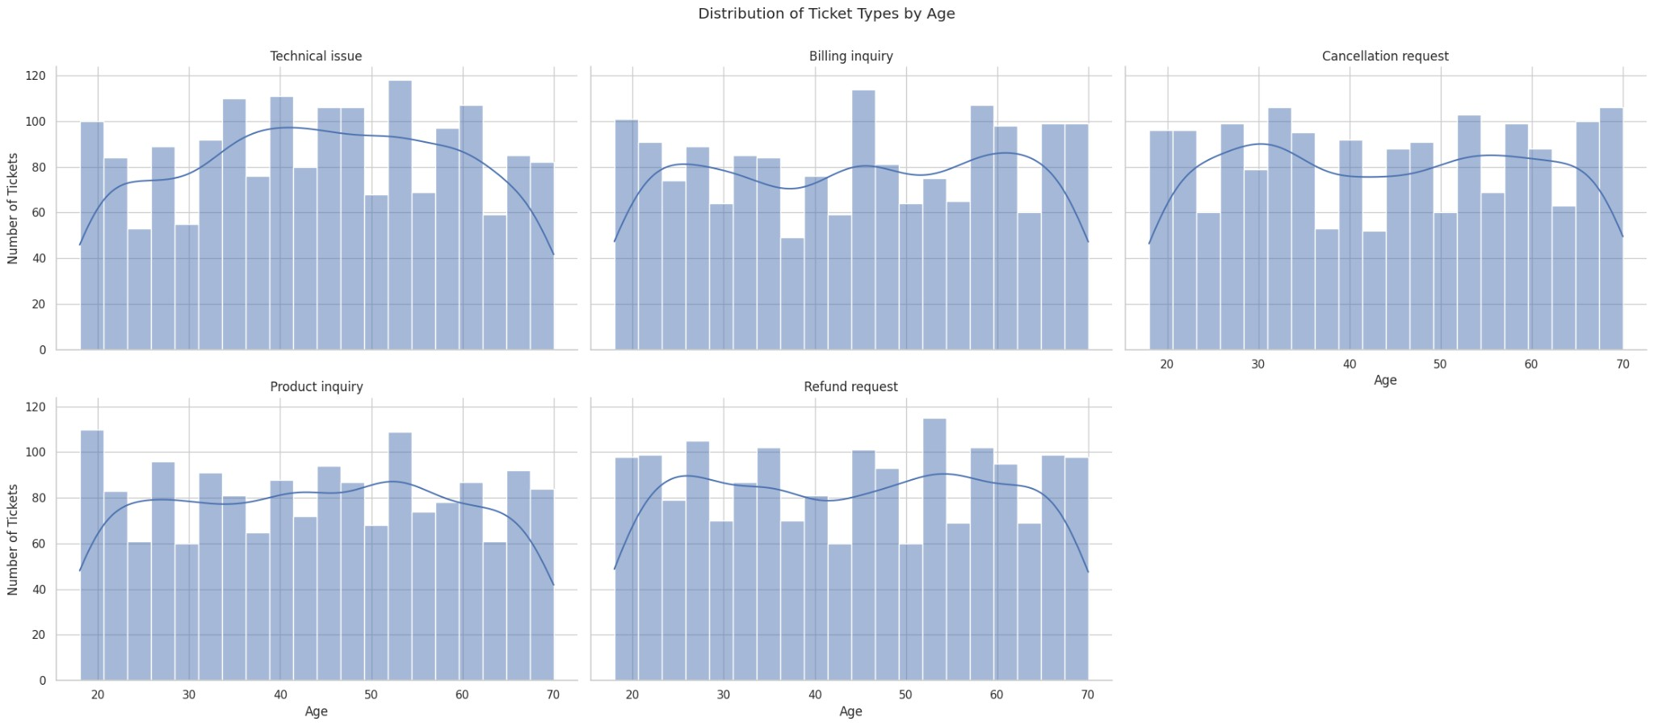

[Reference](https://github.com/praveen-hegde/E-commerce-customer-satisfaction-predicton) [link](https://github.com/praveen-hegde/E-commerce-customer-satisfaction-predicton)